IET DEPARTMENT



Data Structure and Algorithm
Lab Manual
Lab 4 : Linked Lists
Objectives:
- Linked List Concept
- Creating Node
- Inserting Node
- Deleting Node

Introduction
A linked list is a data structure that can store an indefinite number of items. These items are connected using pointers in a sequential manner. This session uses pointers to organize and process data in lists, called linked lists. Recall that when data is stored in an array, memory for the components of the array is contiguous—that is, the blocks are allocated one after the other. However, as we will see, the components (called nodes) of a linked list need not be contiguous.
- A simple real-life example is a Train, here each coach is connected to its previous and next coach (Except first and last). In terms of programming consider coach body as node value and connectors as links to previous and next nodes.

- Consider the history section of web browsers, where it creates a linked list of webpages visited, so that when you check history (traversal of a list) or press back button, the previous node's data is fetched.

Activity Time boxing

Task No. | Activity Name | Activity time | Total Time
1 | Lab Manual Lecture | 30 mins
2. | Example | 10 mins
3 | Walkthrough Tasks | 10 mins
4. | Lab Tasks | 90 mins
5. | Evaluation | 30 mins | 170 mins

Concept Map
Linked List
Implementation of Link list
Display Linked list
Insertion Deletion

Linked List

A linked list is a collection of components, called nodes. Every node (except the last node) contains the address of the next node. Thus, every node in a linked list has two components: one to store the relevant information (that is, data) and one to store the address, called the link, of the next node in the list. The address of the first node in the list is stored in a separate location, called the head or first. Figure 1 is a pictorial representation of a node.

A list of items, called nodes, in which the order of the nodes is determined by the address, called the link, stored in each node.
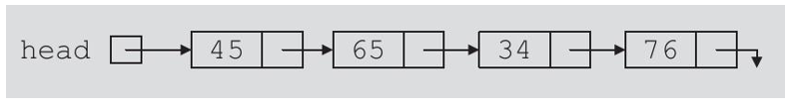
The arrow in each node indicates that the address of the node to which it is pointing is stored in that node. The down arrow in the last node indicates that this link field is NULL.

For a better understanding of this notation, suppose that the first node is at memory location 1200, and the second node is at memory location 1575, see Figure below
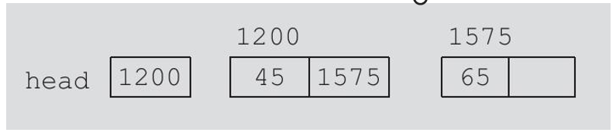
The value of the head is 1200, the data part of the first node is 45, and the link component of the first node contains 1575, the address of the second node. We will use the arrow notation whenever we draw the figure of a linked list.

For simplicity and for the ease of understanding and clarity, above figure use decimal integers as the values of memory addresses. However, in computer memory the memory addresses are in binary.

Because each node of a linked list has two components, we need to declare each node as a class or struct. The data type of each node depends on the specific application—that is, what kind of data is being processed. However, the link component of each node is a pointer. The data type of this pointer variable is the node type itself.

Head and Tail Nodes
No matter how many nodes are present in the linked list, the very first node is called head and the last node is called the tail. If there is just one node created then it is called both head and tail.
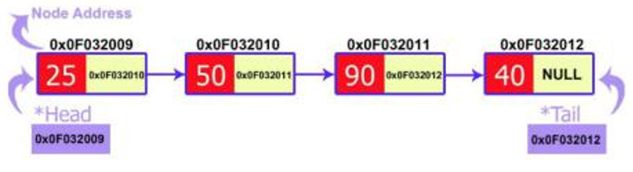

Implementation of node in Linked List (C++)
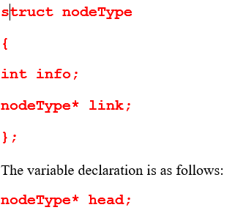

Linked Lists: Some Properties
To better understand the concept of a linked list and a node, some important properties of linked lists are described next.

Consider the linked list in Figure below
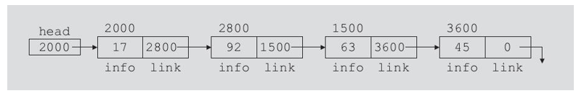
Values of head and some of the nodes of the linked list of above is:
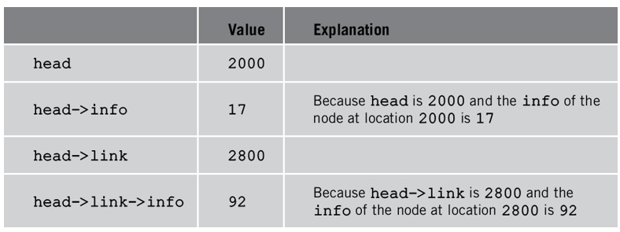
Deletion in Linked List
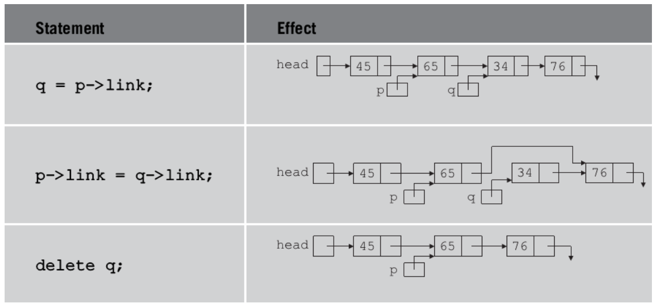
Insertion in Linked List
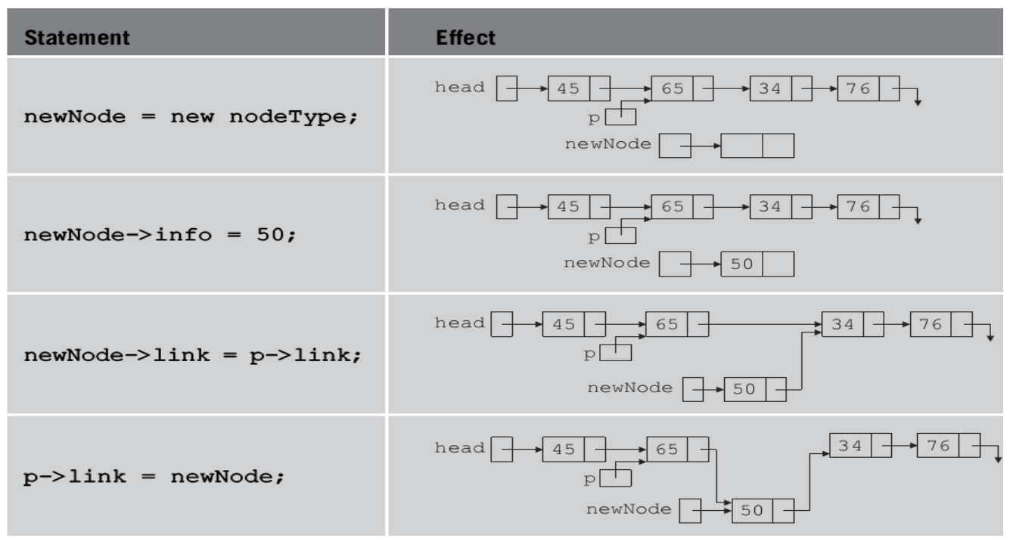

Program Example:

- Traversal:
void traverseLL(Node head) {
while(head != NULL)
{
print(head.data)
head = head.next }}

- Insert at begin:
// function is returning the head of the singly linked-list
Node insertAtBegin(Node head, int val)
{
newNode = new Node(val) // creating new node of linked list
if(head == NULL) // check if linked list is empty
return newNode
else // inserting the node at the beginning
{
newNode.next = head
return newNode
}}
- Insert After given:
void insertAfter(Node prevNode, int val)
{
newNode = new Node(val)

newNode.next = prevNode.next
prevNode.next = newNode
}

Deletion
Node deleteLL(Node head, Node del)
{
if(head == del) // if the node to be deleted is the head node
{
return head.next // special case for the first Node
}
Node temp = head

while( temp.next != NULL )
{
if(temp.next == del) // finding the node to be deleted
{
temp.next = temp.next.next
delete del // free the memory of that Node
return head }
temp = temp.next
}
return head // if no node matches in the Linked List}

Sample Program (Java)
Add Node:
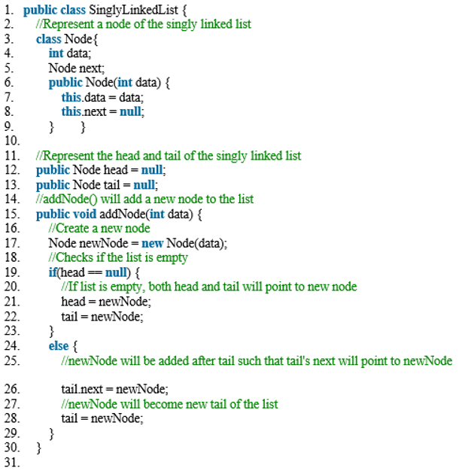

Display Link List
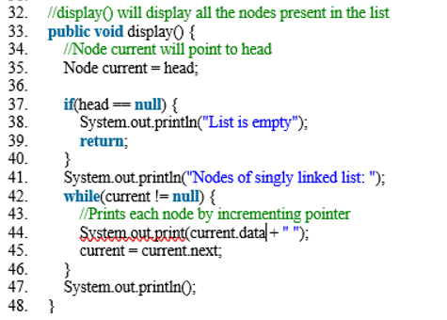

public static void main(String[] args) {
SinglyLinkedList sList = new SinglyLinkedList();
//Add nodes to the list
sList.addNode(1);
sList.addNode(2);
sList.addNode(3);
sList.addNode(4);
//Displays the nodes present in the list
sList.display();
}

Linked List Creation Java Code:
See Following Link:
https://www.geeksforgeeks.org/implementing-a-linked-list-in-java-using-class/

https://afteracademy.com/blog/types-of-linked-list-and-operation-on-linked-list

Practice Tasks
[Estimated Time Minutes: 90 Minutes]

Lab Task 1:
As you have learned how to insert and delete a node at different positions in the link list now you are required to perform the following tasks.
Suppose we have the following singly linked list
Singly Linked list
- Create your own class of link list which will have the following functions.
  - Function called InsertAtBeginto add node at the begging of list.
After insertion of value 12 at the beginning of the linked list, it will become as following:
Insertion at beginning of singly linked list
  - Function called InsertAtEndto add node at the last of list.
After insertion of value 25 at the end of the linked list, it will become as following:
Insertion at the end of the singly linked list
  - Function called update to update the value.
If we want to update the value 20 residing at location 12 to 25, our linked list will display
Updated linked list
  - Function called display to display the list.
In this part display the content of the following linked list
  - Function called search to search the value.
  - Function called insertAfter to insert any value after certain value or key.

Lab Task 2:
Write a class named Mobile that holds data about a mobile in a retail store. The class should have the following member variables:
• Name/brand. A string that holds name of the brand of phone.
• unitsOnHand. An int that holds the number of units currently in inventory.
• price. A double that holds the retail price.
Write a constructor that accepts arguments for each member variable, appropriate functions that store values in these member variables, and accessor functions that return the values in these member variables.
Once you have written the class,
Write another class Store (link list) having Mobile as a node then provide function to insert new mobile in list and to Delete a mobile and to display all mobiles.
Write a main program that shows all the functionality.
Note: you have to implement all scenarios (insert and delete at start, end, in between).

Lab Task 3:
You are required to implement a basic social media portal where a user can create his/her profile
You can provide user the options to create a new profile, update profile and delete profile as well.

Create a class Profile having necessary information of user ( ID, Name, gender, age, email, interest, Date of birth) provide appropriate methods.
Next create a class Portal which uses node of Profile Class to handle profiles. Next provide methods to
- InsertProfile (ID, Name, gender, age, email, interest, Date of birth)// adds new profile to the list.
- UpdateProfile (int id) which helps user to update his/her profile information)
- DeleteProfile(string name)// delete a particular profile form the list
- searchProfile(string name)
- Display ()// display all values.
In main create a menu to show the following options to the user
- Add new Profile
- Update Profile ( which helps user to update his/her profile information)
- Delete a Profile
- Search Profile
- Display All
- Exit.
The program runs until user wants to exit.

Evaluation criteria

The evaluation criteria for this lab will be based on the completion of the following tasks. Each task is assigned the marks percentage which will be evaluated by the instructor in the lab whether the student has finished the complete/partial task(s).

Out comes
The outcomes of this lab were:
- Link list Creation Node
- Insertion in Link list
- Displaying link list

